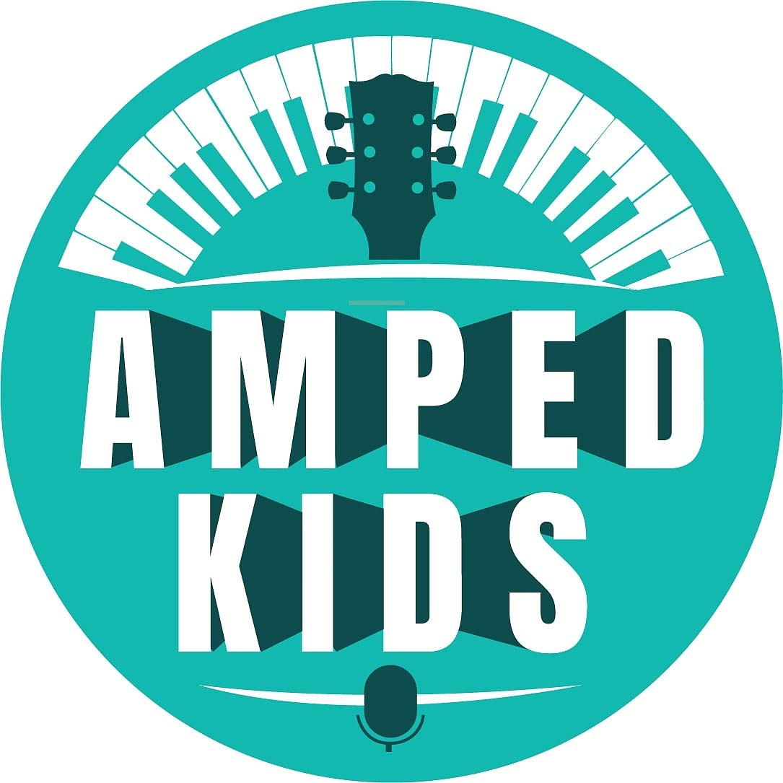

**Amped Kids Foundation**

**Amplify. Grow. Empower.**

**2276 GA 17 Sautee Nacoochee, GA 30571**

**www.Ampedkids.org**

**MISSION STATEMENT**

Amped Kids Foundation is a 501(c)3 non-profit organization providing music education for foster, adopted and at-risk youth. Our mission is to positively impact the lives of youth through music programs and therapeutics providing a pathway of healing for children who have suffered from trauma.